RETAIL ORDER MANAGEMENT PLATFORM

TRELLO BOARD:
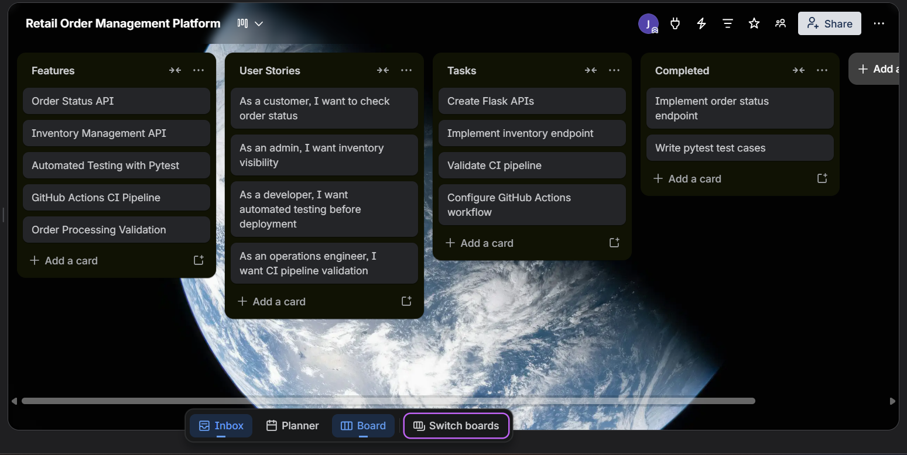

GITHUB REPOSITORY:
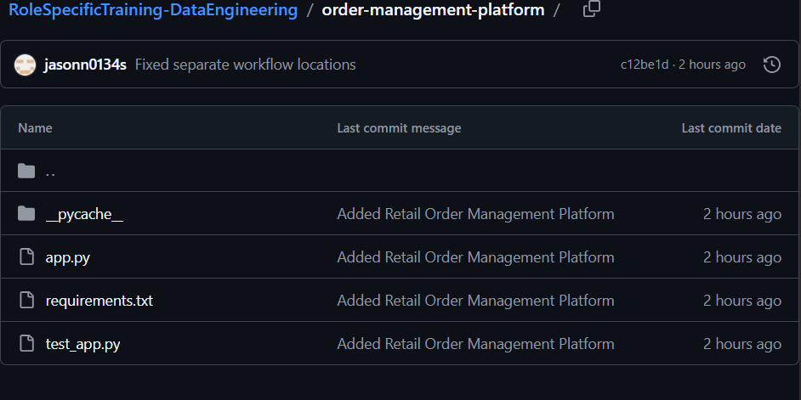

GITHUB PIPELINE CREATION
